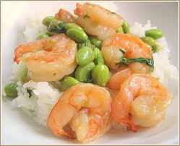

We have made great strides in awareness, early detection, and treatment of breast cancer. Nevertheless, the incidence has increased in recent years – decreasing ONLY in women over 50 since the results of the Women’s Health Initiative convinced many women to discontinue hormone therapy. One in eight girls born today is expected to get breast cancer in her lifetime.

Like other cancers, breast cancer develops when abnormal cells grow and multiply without being destroyed by the immune system.

Every year, billions of dollars are poured into developing drugs to treat breast cancer, but more research is needed to identify the cause(s). Eating a healthy diet and exercising aren’t enough to reduce your risk. Managing stress, reducing toxic exposures, and focusing on key nutrients should be part of every woman’s breast cancer prevention plan.

Whole or fermented soybeans and flaxseeds act as phytoestrogens, which are weak estrogens that can block dangerous estrogens.

Iodine (in sea vegetables), zinc, and selenium have been shown to strengthen the thyroid and adrenals, which support healthy hormone balance.

**Phyto-estrogens**

Managing Stress

Stress can contribute to breast cancer by altering hormonal balance. The adrenal glands normally produce progesterone and DHEA (calming hormones). With prolonged stress, the body continuously produces cortisol (stress hormone), which shifts the balance from protective estrogen to cancer-causing estrogen. Cortisol also reduces immune function and melatonin production, interfering with sleep and making the body more vulnerable to cancer.

Yoga, Tai Chi, meditation, counseling, and spiritual practice can be helpful to manage stress.

**Misguided Efforts**

What to Avoid

* Birth Control Pills
* HRT (synthetic forms)
* Mercury amalgam fillings (have removed safely)
* Personal care products containing pthalates, sulfates, chemical sunscreens
* Conventially raised meat and dairy (grain-fed, pesticides)
* Non-organic produce (GMOs, pesticides)
* Sugar and simple carbohydrates
* Products like crackers and chips (high omega-6 oils–sunflower, safflower, soybean oils)
* Alcohol (over one glass red wine/day)
* Chronic stress

**Selenium, Iodine, and Zinc**

**100% grass-fed meat and dairy  
Pumpkin seeds  
Brazil nuts  
Tuna  
Sea vegetables**

**Omega-3 Fatty Acids**

**Wild-caught fatty fish**

**100% grass-fed meat and dairy**

**Whole/ fer-mented soy (edamame, miso, tempeh)**

**Flaxseeds**

**Black Beans**

**Sesame Seeds**

Some breast cancers are fed by estrogen that has become toxic. Xenoestrogens are foreign substances that act like estrogen in the body. Xenoestrogens can come from toxins in food, air, water, and personal care products, as well as plastics used to store food and beverages. Body fat also produces and stores estrogen.

Eating only organic meat and produce will reduce dietary xeno-estrogens. Eating foods rich in sulfur, protein, vitamins and minerals, and fiber helps the liver detoxify and remove estrogens.

**Best Food Choices**

**Sulfur Vegetables**

**Broccoli**

**Cauliflower**

**Cabbage**

**Bok Choy**

**Kale**

**Arugula**

**Onions**

**Garlic**

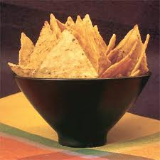

**Diet and Lifestyle for Breast Cancer Prevention**

## How Can Diet Changes Help?

Healing Nutrition of Sonoma  
Maria Bachteal, Nutrition Consultant